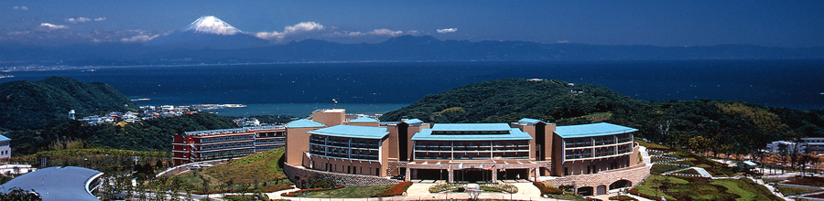
ICSRI
Hayama, Kanagawa, Japan, 2-4 Oct., 2013
Early payment due date is extended to 26th July, 2013.
International Conference on Smart Carbon Saving and Recycling for Ironmaking (ICSRI) https://www.isij.or.jp/mukrwsngl

ICSRI Registration and Accommodation Form

Fill the following inquiries and return your form to both Ueda, Prof., Tohoku Univ., tie@tagen.tohoku.ac.jp, and Matsumoro, Mr., Shonan Village Center, matsumoto@shonan-village.co.jp , please. The total fees of registration and accommodation is asked to be paid only by bank transfer the following instruction.

* required terms. Check the selected box like ”x”, please
1. Personal Information
*First Name
Middle Name
*Last Name
*Affiliation
*Title |  | Prof. Dr. Mr. Ms. Mrs.
*Status |  | Student ⇨ Not student, Business person
Presentation |  | ⇨ I am planning / ⇨ Not to plan
*E-mail Address
*E-mail Address (Retype)
*Phone Number
Fax Number
*Postal Address
*City
State/Province
*Country
Zip code
2. Registration and Accommodation
*Registration Fee | *Check the  * Registration fee includes conference materials, reception and banquet events and coffee breaks.  * Registration cancel refund of 80% of the original fee is available until 26th July, 2013. After 26th July, 2013, refund will be not acceptable.
   | Regular | Student
  Early payment by 26th July 15th July, 2013 | □20,000 JPY | □10,000 JPY
  Previous registration by 15th September, 2013 | □25,000 JPY | □15,000 JPY
  Registration desk in the conference | □30,000 JPY | □20,000 JPY
3. Accommodation and Bus tour
* Accommodation | *Check the  *Two-nights shared twin room (2nd-4th October) accommodation fee includes two breakfasts (3, 4 Oct),a lunch (3 Oct). Personal reservation (2nd or 3th October) one includes a breakfast (3 or 4 Oct), a lunch (3 Oct).  *Accommodation cancel refund of 80% of the original fee is available until 31st August, 2013. After 1st September, 2013, refund will be not acceptable.  *The receipt will be passed to the participant during the conference.
  Two-nights shared twin room (2nd-4th October) accommodation in the Shonan Village Center | □20,000 JPY/person
  Personal reservation in the center on 2nd October | □15,000 JPY/person
  Personal reservation in the center on 3rd October | □15,000 JPY/person
Gender | □ Male / □ Female
Food preference | □ No preference / □ Vegetarian (prepared as possible as we can)
Bus Excursion | □ Participate / □ Absent (on 4 Oct, 12:30- around 17:00, Free charge)
4. Payment
* Total fee | JPY (Registration + Accommodation)
How to pay | The total fee is required to be paid by a bank-transfer to the following bank account.  ICSRI office (Shigeru Ueda)  Paying bank :MIZUHO BANK, LTD.  A/C with branch: SENDAI BRANCH  Address: 3-1-1 Ichibancho Aobaku Sendai city Miyagi pref. Japan  SWIFT CODE: MHBKJPJT  A/C Number: 723-4774438  A/C Holder: ICSRI  * Commission fee for the bank transfer is asked to be paid by the payer, please. *The receipt will be passed to the participant during the conference.
Payment plan | I will transfer my fee by / (MM/DD), 2013.
5. Inquiries
Please, ask freely to the following persons,
*Accommodation Inquiry: Kei Matsumoto, Mr., Shonan Village Center,
E-mail: matsumoto@shonan-village.co.jp
TEL +81 (0)46-855-1801 FAX +81 (0)46-855-1816
*Registration and Payment process inquiry: Shigeru Ueda, Assoc. Prof., Tohoku University,
E-mail: tie@tagen.tohoku.ac.jp , Phone: +81 (0)22-217-5159
*General inquiry: Yukitaka Kato, Assoc. Prof., Tokyo Institute of Technology
E-mail: yukitaka@nr.titech.ac.jp, Phone: +81 (0)22-217-5159
Return your form to both tie@tagen.tohoku.ac.jp, and matsumoto@shonan-village.co.jp , please. Thank you!

